Q01. Given an m x n grid and a ball at a starting cell, find the number of ways to move the ball out of the grid boundary in exactly N steps??

CODE:

m, n, N, start_i, start_j = 2, 2, 2, 0, 0

dp = [[[0 for _ in range(n)] for _ in range(m)] for _ in range(N+1)]

directions = [(-1, 0), (1, 0), (0, -1), (0, 1)]

dp[0][start_i][start_j] = 1

total_ways = 0

for steps in range(1, N+1):

new_dp = [[[0 for _ in range(n)] for _ in range(m)] for _ in range(N+1)]

for i in range(m):

for j in range(n):

for di, dj in directions:

ni, nj = i + di, j + dj

if 0 <= ni < m and 0 <= nj < n:

new_dp[steps][i][j] += dp[steps-1][ni][nj]

else:

total_ways += dp[steps-1][i][j]

dp = new_dp

print(total_ways)

OUTPUT: 6

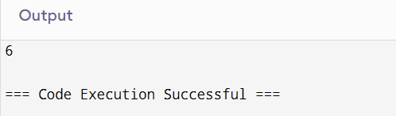

Q 02.You are a professional robber planning to rob houses along a street. Each house has a certain amount of money stashed. All houses at this place are arranged in a circle. That means the first house is the neighbor of the last one. Meanwhile, adjacent houses have security systems connected, and it will automatically contact the police if two adjacent houses were broken into on the same night ??

CODE:

def rob_linear(houses):

if len(houses) == 0

return 0

if len(houses) == 1:

return houses[0]

dp = [0] * len(houses)

dp[0] = houses[0]

dp[1] = max(houses[0], houses[1])

for i in range(2, len(houses)):

dp[i] = max(dp[i-1], houses[i] + dp[i-2])

return dp[-1]

def rob_circle(houses):

n = len(houses)

if n == 0:

return 0

if n == 1:

return houses[0]

return max(rob_linear(houses[1:]), rob_linear(houses[:-1]))

houses = [2, 3, 2]

print(rob_circle(houses))

houses = [1, 2, 3, 1]

print(rob_circle(houses))

OUTPUT:3,4

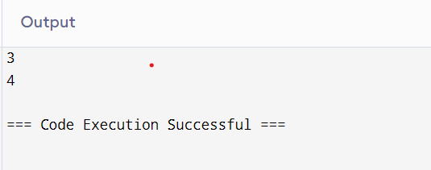

Q 03.You are climbing a staircase. It takes n steps to reach the top. Each time you can either climb 1 or 2 steps. In how many distinct ways can you climb to the top?

CODE:

n=4

a,b=1,2

for i in range(n-1):

a,b=b,a+b

print(a)

OUTPUT:5

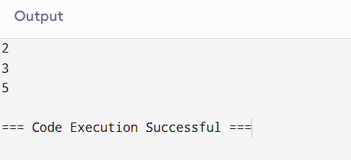

Q 04.A robot is located at the top-left corner of a m×n grid .The robot can only move either down or right at any point in time. The robot is trying to reach the bottom-right corner of the grid. How many possible unique paths are there?

CODE:

def uniquePaths(m, n):

dp = [[1] * n for _ in range(m)]

for i in range(1, m):

for j in range(1, n):

dp[i][j] = dp[i-1][j] + dp[i][j-1]

return dp[m-1][n-1]

m = 3

n = 7

print(uniquePaths(m, n))

OUTPUT:28

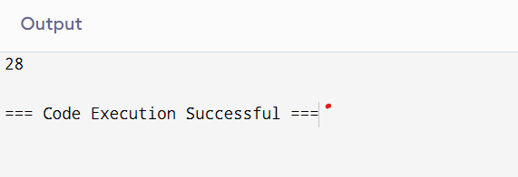

Q 05.In a string S of lowercase letters, these letters form consecutive groups of the same character. For example, a string like s = "abbxxxxzyy" has the groups "a", "bb", "xxxx", "z", and "yy". A group is identified by an interval [start, end], where start and end denote the start and end indices (inclusive) of the group. In the above example, "xxxx" has the interval [3,6]. A group is considered large if it has 3 or more characters. Return the intervals of every large group sorted in increasing order by start index ??

CODE:

def largeGroupPositions(S):

result = []

n = len(S)

i = 0

while i < n:

start = i

while i < n - 1 and S[i] == S[i + 1]:

i += 1

end = i

if end - start + 1 >= 3:

result.append([start, end])

i += 1

return result

s = "abbxxxxzyy"

print(largeGroupPositions(s))

s = "abcdddeeeeaabbbcd"

print(largeGroupPositions(s))

OUTPUT: ([3,6])

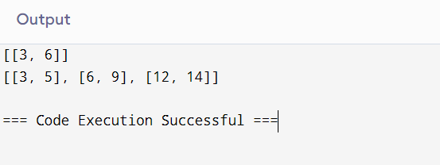

Q 06."The Game of Life, also known simply as Life, is a cellular automaton devised by the British mathematician John Horton Conway in 1970." The board is made up of an m x n grid of cells, where each cell has an initial state: live (represented by a 1) or dead (represented by a 0). Each cell interacts with its eight neighbors (horizontal, vertical, diagonal) using the following four rules Any live cell with fewer than two live neighbors dies as if caused by under population.

CODE:

def gameOfLife(board):

m, n = len(board), len(board[0])

def count_live_neighbors(r, c):

directions = [(-1, -1), (-1, 0), (-1, 1), (0, -1), (0, 1), (1, -1), (1, 0), (1, 1)]

live_neighbors = 0

for dr, dc in directions:

nr, nc = r + dr, c + dc

if 0 <= nr < m and 0 <= nc < n and abs(board[nr][nc]) == 1:

live_neighbors += 1

return live_neighbors

for i in range(m):

for j in range(n):

live_neighbors = count_live_neighbors(i, j)

if board[i][j] == 1:

if live_neighbors < 2 or live_neighbors > 3:

board[i][j] = -1

else:

if live_neighbors == 3:

board[i][j] = 2

for i in range(m):

for j in range(n):

if board[i][j] == -1:

board[i][j] = 0

elif board[i][j] == 2:

board[i][j] = 1

board = [

[0, 1, 0],

[0, 0, 1],

[1, 1, 1],

[0, 0, 0]

]

gameOfLife(board)

print(board)

OUTPUT:[[0,0,0],[1,0,1],[0,1,1],[0,1,0]]

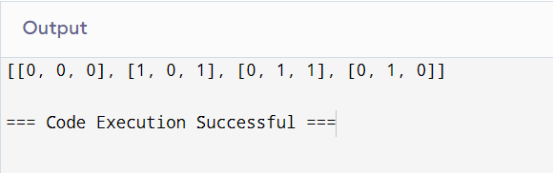

Q 07.We stack glasses in a pyramid, where the first row has 1 glass, the second row has 2 glasses, and so on until the 100th row. Each glass holds one cup of champagne. Then, some champagne is poured into the first glass at the top. When the topmost glass is full, any excess liquid poured will fall equally to the glass immediately to the left and right of it. When those glasses become full, any excess champagne will fall equally to the left and right of those glasses, and so on..

CODE:

def champagneTower(poured, query_row, query_glass):

glasses = [[0] * k for k in range(1, 102)]

glasses[0][0] = poured

for row in range(100):

for col in range(row + 1):

if glasses[row][col] > 1:

excess = glasses[row][col] - 1

glasses[row][col] = 1

glasses[row + 1][col] += excess / 2.0

glasses[row + 1][col + 1] += excess / 2.0

return min(1, glasses[query_row][query_glass])

poured = 4

query_row = 2

query_glass = 1

print(champagneTower(poured, query_row, query_glass))

OUTPUT: 0.5

